ECSE 211 Design Principles and Methods

**Capture the Flag Robot:**

**Completion Report**

Prepared for:

Professor Lowther & Professor Ferrie

Faculty of Engineering, McGill University

Prepared by:

Rahul Amlekar

Daniele Bercovici

William Bouchard

Alessandro Commodari

Ryan

Asher Wright

Team 14

December 4, 2015

TABLE OF CONTENTS

LIST OF FIGURES & TABLES ii

1. INTRODUCTION 1

2. METHODS 2

2.1 Requirements 2

2.2 Design solution 2

2.2.1 Beam with low volume……………………………………………………...4

2.2.2 Beam with high volume…………………………………………………..…4

2.2.3 Beam optimized for printer………………………………………………….4

2.3 Testing 5

2.4 Equipment used and material properties…………………………………….…..5

3. RESULTS 6

4. CONCLUSIONS 7

5. RECOMMENDATIONS 10

LIST OF REFERENCES 11

APPENDIX A: Detailed Calculations 12

APPENDIX B: SolidWorks Drawings 18

# LIST OF FIGURES & TABLES

**Figures** **Page**

Figure 2.2.1 – Labelled cross section of an I-beam 3

**Tables**

Table 2.4.1 – Properties of rapid prototyping plastic 5

# INTRODUCTION

The purpose of this report is to detail the design and testing of a simply supported beam, and analyze the results. The client required a 3-D printed beam, 250 mm in length, with a maximum deflection of 1.2 ± 0.05 mm given a 2.0 kg applied load. The assigned task was to create this beam, test it, and report the findings in three weeks.

This report will cover the details of the beam, the results of testing, the conclusions from testing, and the recommendations for improvement. Although recommendations will be made, this report will not provide a new optimized solution.

The most significant finding was that an I-beam is an effective solution to the design problem. It can be easily manipulated to deflect a desired amount while keeping internal stress at a minimum. During testing, the printed beam deflected 1.26 mm, which is 0.01 mm beyond the desired range. This error will be analyzed in the results section of the report. This report recommends that for 3-D printed beams, with constant moments of inertia, dimensions and volumes should be maximized in order to minimize sources of error.

This report is organized chronologically. It will first review the requirements, the design solution, and the testing method. It will give the results found from testing. Proceeding, the report will present conclusions based on these results, and analyze possible sources of error. Finally, this report will make recommendations based on the conclusions.

# METHODS

To meet the client’s needs, our group looked over the requirements and constraints, brainstormed multiple solutions, chose the best solution, and then examined the method of testing.

## Requirements

The technical problem was to design a 3-D printed beam with a specific goal. This goal was to have a maximum deflection of 1.2 ± 0.05 mm under a load of 2.0 kg, at a span of 230 mm. The two main requirements of the team were SolidWorks software to design the beam, and a rapid prototyping machine (with materials data) to print the beam. The team also had to consider the constraints. Firstly, the beam had to be 250 mm long. Secondly, the total volume had to be less than 20.0 cm­­3. Lastly, the beam could not be hollow.

## Design solution

A goal was set to create at least two potential designs, and then decide on the best design to print. The beginning of the design process was the same for each potential beam. The processes only started to diverge when different restrictions were made.

Research showed that, for this specific beam system, a formula existed to calculate the maximum deflection (Hibbeler, 808). This relationship is shown in Eq. (1):

 (1)

where:

 = maximum deflection of beam

*P* = force applied to center of beam

*l* = length of gap

*E*  = modulus of elasticity of the material

*I*  = moment of inertia of cross sectional area.

Examining this relationship, one can see that the maximum deflection is dependent on the force, the length of the gap, the modulus of elasticity of the material, and the moment of inertia. In this case, the required deflection was 1.2 mm, the force was a constant 2.0 kg, the length of the gap was a constant 230 mm, and the material had a constant modulus of elasticity of 2.25 GPa (see Table 2.4.1 below). Thus, the only unknown variable was the moment of inertia. Using Eq. (1), the moment of inertia was found to be 1.842 (10-9)m4. See Appendix A for the detailed calculations. Although this moment of inertia was constant, many different shapes and sizes of cross sections could yield this value.

The next step was to choose a shape for the beam. An I-beam provides excellent resistance to bending stress, as it “reduces mass without compromising strength.” (PASCO, 1). For these reasons, the group selected an I-beam with general cross section as shown below in Figure 2.2.1.

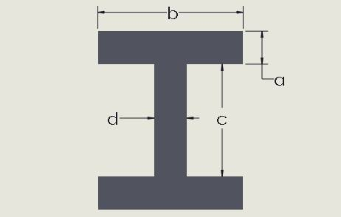

Figure 2.2.1 – Labelled cross section of an I-beam

The relationship between the moment of inertia for the I-beam and the dimensions of the I-beam was calculated (See Appendix A for details). This is shown by Eq. (2):

 (2)

where:

*a*, *b*, *c*, *d* = dimensions as labeled in Figure 2.2.1.

The next step was to set constraints on the cross section so that the dimensions could be calculated. Three different beams were designed, each with specific constraints. The first constraint was that the thickness of the web, labelled “d”, was equal to the thickness of the flange, labelled “a”. This constraint was applied to all three designs. From this point, the three beams were fleshed out individually. See Appendix B for dimensioned drawings of the following three beams.

* + 1. Beam with low volume

The first beam design had a constraint that set the volume to 12.5 cm3, which was 7.5 cm3 below the maximum. This beam used little material and was much thinner and taller than the other beams.

* + 1. Beam with high volume

The second beam had a constraint that set the volume to 19.75 cm3, which was 0.25 cm3 below the maximum. This beam used much more material than the low volume beam. It was shorter and less wide than the low volume beam, but the web and flanges were thicker. The higher volume increased the cross sectional area, and thus decreased the internal stress.

* + 1. Beam optimized for printer

The third beam, chosen as the final design, was optimized for the rapid prototyping machine. Creating a beam optimized for the printer removed unnecessary sources of error. This beam was based off the design of the high volume beam. It was created after finding out that the resolution of the rapid prototyping machine was 0.5 mm, which was less precise than the expected 0.1 mm. To optimize the beam, all of the dimensions were constrained to be multiples of the printer resolution (0.5 mm). If this were not the case, the printer would likely leave a gap or place too much or too little material for some dimensions. After setting these constraints, the exact dimensions of the beam were calculated. The moment of inertia of the beam was found to be slightly lower than the desired value. To account for this change, fillets were added between the web and flanges. These fillets corrected the moment of inertia (confirmed with SolidWorks) and also decreased the likelihood of breaking from twisting.

The third beam was selected for the final design because it minimized sources of error from the printer while providing a desirable moment of inertia and low internal stress. See Appendix A for the full calculations of the beam.

## Testing

The apparatus used to test the beam was simply constructed. Two wooden boards supported metal rollers that were spaced 230 mm apart. The beam was placed symmetrically on top of the rollers. A spring loaded analog micrometer was positioned above the beam to measure the deflection. A string hoop was then put around the beam and moved to the center. The 2.0 kg mass was hooked on this string, and released slowly, until the beam reached maximum deflection. The mass was completely released, and Mr. Harding measured deflection. This was an effective method to test the beam as it ensured that a precise measurement of the deflection could be made. See Figure 2.3.1 below for the testing layout.

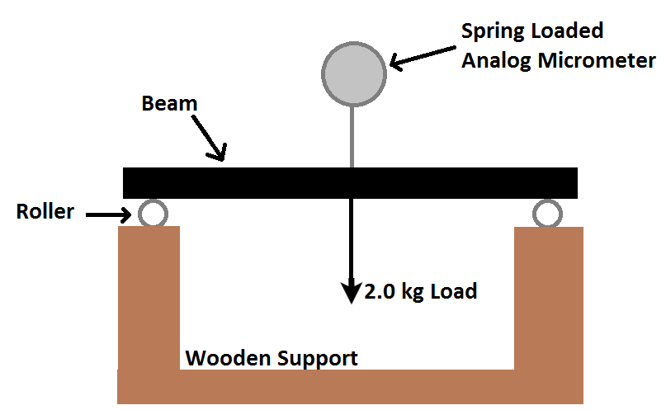

Figure 2.3.1 – Side view of testing system

* 1. **Equipment Used and Material Properties**

The equipment used to print the beam was Dalhousie Engineering’s Rapid Prototyping machine. The material used was Rapid Prototyping plastic See Table 2.4.1 (information taken from client’s project outline) below for the properties of the material.

Table 2.4.1–Properties of rapid prototyping plastic – data from (Matthew Harding, 2014)

|  |  |  |  |
| --- | --- | --- | --- |
| **Mechanical Properties** | **Test Method** | **Objet** | **Dimension** |
| Tensile Strength (Type 1, 0.125", 0.2 "/min) | ASTM D638 | 50-65 MPa | 37 MPa |
| Tensile Modulus (Type 1, 0.125", 0.2 "/min) | ASTM D638 | 2,000 MPa | 2,320 MPa |
| Tensile Elongation (Type 1, 0.125", 0.2 "/min) | ASTM D638 | 10% - 15% | 3% |
| Flexural Delamination | ASTM D790 |  | 31 MPa |
| Flexural Strength (Method 1, 0.05"/min) | ASTM D790 | 75 - 100 MPa | 53 MPa |
| Flexural Modulus (Method 1, 0.05"/min) | ASTM D790 | 2.2 - 3.2 GPa | 2.25 GPa |
| IZOD Impact, notched (Method A, 20°C) | ASTM D256 | 20-30 J/m | 106 J/m |

**3. RESULTS**

This results section will focus on the results found from testing, and will not present any implications of these results. These results will be presented objectively, and then compared to the general results of other groups. Further analysis will be presented in the conclusions section.

The proposed beam was tested in the previously described setup, and the results were recorded. During testing, the beam deflected as expected when the mass was applied. The maximum deflection of the beam was 1.26 mm. The beam did not appear close to breaking from internal stresses. After the mass was removed, the beam returned to its original, non-bent, state.

The deflection of 1.26 mm is relatively close to the desired or theoretical deflection of 1.20 ± 0.5 mm. The absolute difference between the experimental value and the theoretical value is 0.06 mm. The percent error of the experimental value is thus 5.0%. This relatively low percent error shows that the experimental data compared closely to the theoretical data.

Beams designed by other groups tended to over-deflect by roughly 0.20 mm. It was found that tall I-beams, X-beams, and any beams with small cross-sectional areas deflected more than higher area beams, such as shorter I-beams.

Overall, it was observed that the maximum deflection of most beams was consistently higher than the theoretical value. Additionally, it was seen that beams with higher cross sectional areas tended to deflect less than other beams.

# CONCLUSIONS

This conclusion will look at the results of the beam, as well as the general results of the beams designed by other groups. It will explore deflection trends, and examine potential sources of error.

The beam deflected 1.26 mm, a relative error of 5.0 %. This result is close to the desired range, meaning the process and equations used to design the beam were effective. It was observed that most beams tended to over-deflect. Possible sources of this error include error from printing, error from measurement, and most significantly, error from assuming perfectly elastic behaviour.

Printer error was minimized, but the beam was still printed in layers, with small gaps in the material, as seen in Figure 4.1. These limitations on the beam from the printer resulted in a non-homogeneous beam. One of the assumptions for Eq. (1), the deflection of the beam, was that the material was homogeneous. Thus, this error could have affected the maximum deflection, although likely minimally.

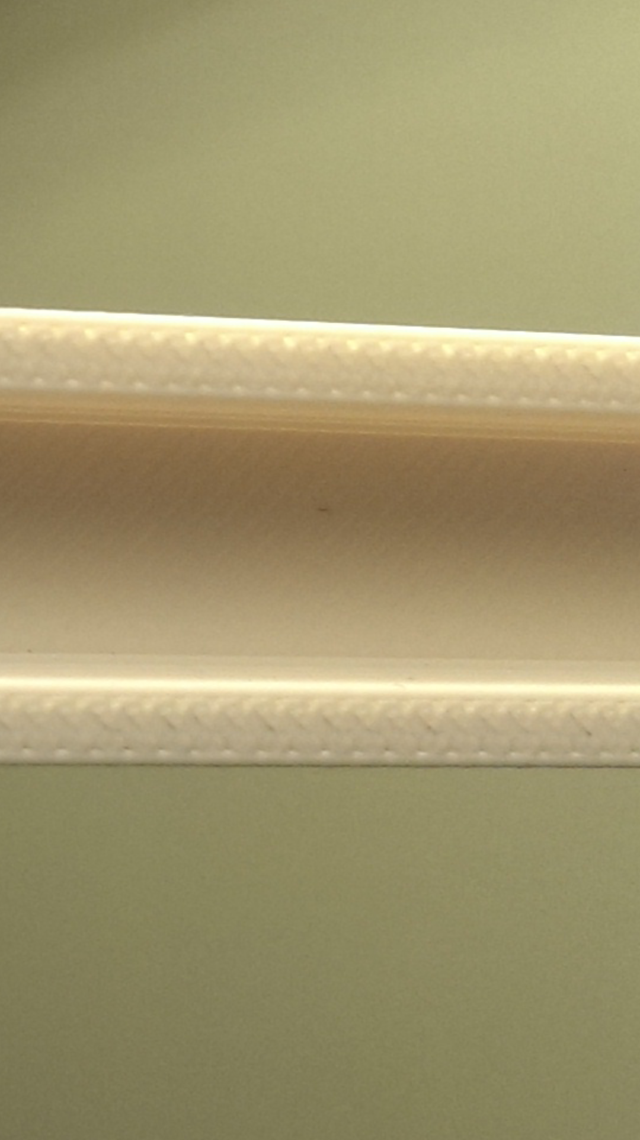

Figure 4.1 – Close up of printed beam

Measurement error includes uncertainties in the applied force and uncertainties in the length of the gap. As can be seen from Eq. (1), the deflection is proportional to the applied force. A minor change in the mass (force) would not significantly affect the deflection. For example, there would have to be a 15 g error in the mass to change the deflection by 0.1 mm. Conversely, deflection is proportional to the length of the gap cubed, and thus a change of the gap by as little as 1.0 mm would change the maximum deflection by 0.16 mm.

The most significant contribution to the error is the assumption of a linearly elastic region for the rapid prototyping plastic. With non-brittle materials, such as A-36 steel, there is a region of elasticity in which stress is proportional to strain. The proportionality constant is the modulus of elasticity, E. With a plastic material, such as the material used to create the beam, this region is much smaller or even non-existent. The stress-strain diagrams for a ductile material and for a brittle (plastic) material are shown in Figure 4.2 and Figure 4.3, respectively. These are for reference only, and neither material referred to by the graphs was used in this project.

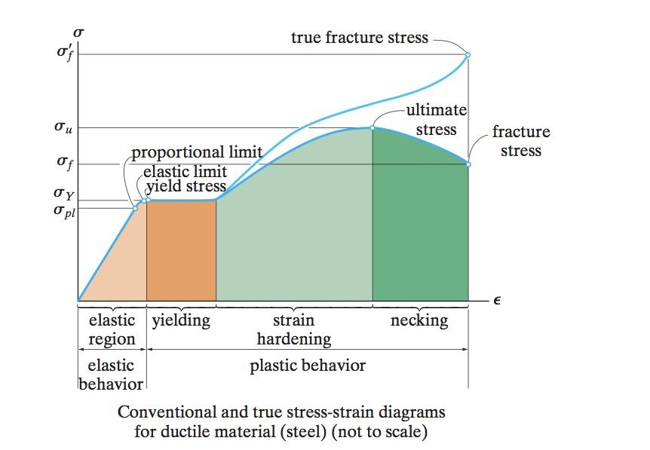 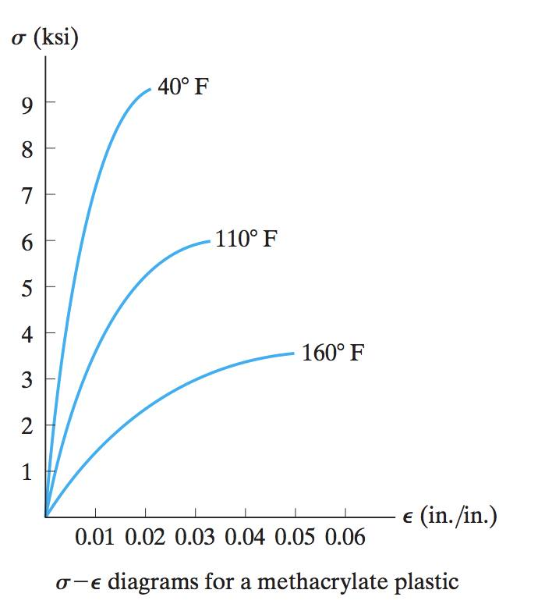

Figure 4.2 – Ductile stress-strain (Hibbeler, 84) Figure 4.3 – Brittle stress-strain (Hibbeler, 90)

As the elastic region for the rapid prototyping plastic was likely small, the modulus of elasticity used in the bending formula was only valid if the internal stress was relatively low. In order to keep internal stress low, the cross sectional area must have been relatively high. With the selection of the high volume beam optimized for the printer, the cross-section area was kept relatively low. Other tested beams that deflected more than the desired range tended to have smaller cross sectional areas. These beams were similar to the proposed solution, in that they usually had the same moment of inertia. However, the internal stresses from bending were much greater than higher area beams. This stress resulted in the beam passing the elastic region, and deforming plastically. Thus, Eq. (1) would no longer be valid for estimating the maximum deflection.

The observed maximum deflection of 1.26 mm is reasonably close to the client’s requested deflection. This validates Eq. (1) for the presented I-beam shape. However, this equation is only valid for elastically behaving materials. Thus, the internal stresses must not push the material past its elastic limit. For the stress to be minimized, the cross-sectional area must be maximized. This explains why beams with larger cross-sectional areas tended to deflect less (and closer to the desired deflection). Although this assumption of elastic behaviour was the largest source of error, there were other sources of error, including printer error, and measurement error. If either of these errors were reduced, it is also expected that the beam would perform closer to the theoretical predictions. This would allow for more accurate beam design for the client in the future.

# RECOMMENDATIONS

The proposed design solution was just outside of the client’s performance criteria. In order to improve the performance of our beam design, we recommend the following:

* Increase the cross-sectional area without changing the moment of inertia, in order to further decrease bending stress.
* Test the current beam further to obtain more data for analysis.
* Create a more homogeneous beam using a higher resolution printer or a mold.
* Test the homogeneous beam and compare the results to the theoretical results and to the results of the original beam.
* Create a beam made of a ductile material to ensure elastic behaviour.
* Test the ductile beam and compare the results to the theoretical results and to the results of the original beam.

# LIST OF REFERENCES

Hibbeler, R.C. (2008). *Mechanics of materials* (7thed.).Upper Saddle River, N.J.: Prentice Hall.

Investigate structural properties of an I-Beam. (n.d.).PASCO :*Engineering : Structural properties of an I-Beam*. Retrieved April 6, 2014, from http://www.pasco.com/engineering/structural-properties-of-an-i-beam.cfm

# APPENDIX A: Detailed Calculations

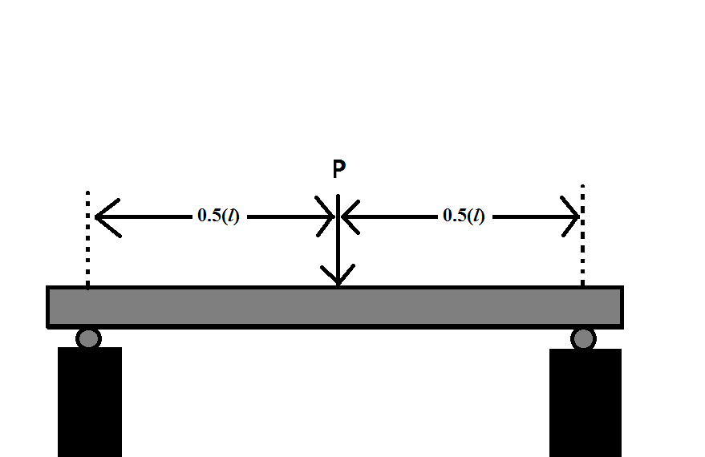

The maximum deflection for a beam support as shown (to the right) is:



where:

 = maximum deflection

*P =* force applied on the beam

*l =* length of the gap

*E =* modulus of elasticity for the material

*I =* moment of inertia.

Calculating the force…

=

We can rearrange for the equation for maximum deflection to solve for *I.*

==

Looking at the cross section of an I-beam, we have four key sides dimensioned with variables as shown in the figure below.

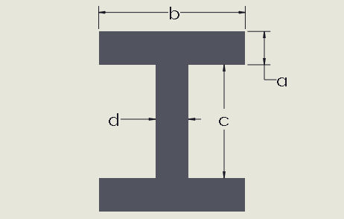

To simply calculations, restrictions will be set such that:

* 
* 
* volume =…

With the restriction the volume can be found through the equation…



Applying the restriction and simplifying the equation for volume of the beam generates…



*I* is the moment of inertia of the cross sectional area about the neutral axis. Therefore*, I*for the beam will be the sum of the *I*values of the web and the two flanges.





The equation for is:



Simplifying, the equations for  becomes:



The equation for is:



The equation for the moment of inertia is:





Using the assumption that, the equation simplifies to:



Plugging in our calculated value for the moment of inertia produces the equation:



A system of equations was generated using the constant *a*, *b*, and *c*. This system included equations for the moment of inertia and the volume, as well as the restriction that. Using WolframAlpha (online calculator) to solve this system, values for the constant were found to be:



To optimize this for printing, lengths were adjusted to 0.5 mm complying with the resolution for the 3-D printer. *a* and *c* were rounded to the closest 0.5 mm increment and *b* was rounded to the nearest 0.5mm increment that created a moment of inertia less than our desired moment of inertia (expressed mathematically below).



With these conditions:



The moment of inertia for these values is:





Note that as seen below, with this moment of inertia the deflection should still be within the given range of.

=

To reduce stress concentrations and optimize the deflection of our beam fillets were added to the beam. Calculations in SolidWorks showed that fillets of 1.25 mm (as shown by the image below) gave a moment of inertia .

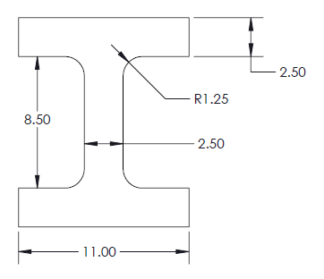

Rounding to four significant figures, this moment of inertia is exactly equal to our desired moment of inertia.

Thus, our final beam had fillets of 1.25mm and dimensions of:



Note: the fact that the fillets produced dimensions that were not 0.5 mm increments was considered. The reduced stress concentrations and moment of inertia closer to the desired value justified adding the uncertainty of having values outside the 0.5 mm resolution for small portions of the beam. Furthermore, calculations showed that even if the fillets didn’t print due to resolution errors the deflection would be, which is still within the range of the desired deflection of 

Calculating Internal Stresses:

Shear and moment diagrams will be given as functions of x, where x = 0 is a point at the roller. These will be used to find the maximum moment.

 occurs at 0.115m











The maximum normal stress is 4.13 MPa. This is significantly lower than the flexural strength of 53MPa. Thus, the beam would likely not break under a 2.0kg load.

# APPENDIX B: SolidWorks Drawings